VALUER REPORT UID NO.:CEV/RVO/299/1402/24032022 24.03.2022

To,
The AGM
Bank Of Baroda
Br. :Sector- 11, Panchkula

VALUATION REPORT ( IN RESPECT OF LAND / SITE AND BUILDING)
I | General
1. | Name of Applicant/ Prospective & Their shares and Mob/Phone No |  |  |  |  | M/s Royal Poultry Farm
2. | Name of Reported /legal owner(s) & their shares & their Mob/Phone No. |  |  |  |  | M/s Royal Poultry Farm
3. | Purpose of valuation |  |  |  |  | To assess present Value of property for bank purposes
4. | List of documents produced in support of Perusal |  |  |  |  | (i) Copy of Old Valuation Report of Er. Sanjay Puri, Dated: 14-03-2019.
5. | Location/ Description of the Property |  |  |  |  | M/s Royal Poultry Farm at Village Behra, Tehsil-Derabassi, Distt. SAS Nagar Mohali-140507
6. | Postal address of Property/Asset |  |  |  | : | M/s Royal Poultry Farm at Village Behra, Tehsil-Derabassi, Distt. SAS Nagar Mohali-140507.
7. | Boundaries of the property |  |  |  |  | As Per Deed |  |  |  |  | Actual
 | North |  |  |  |  | NA |  |  |  |  | Other’s property
 | South |  |  |  |  | NA |  |  |  |  | M/s Alfa Poultry farm
 | East |  |  |  |  | NA |  |  |  |  | Front Paver tile Road
 | West |  |  |  |  | NA |  |  |  |  | M/s Alfa Poultry Farm /other’s prop.
8. | Details of Corporation Tax Paid |  |  |  | : | Details with Owner
9. | Details of Approval If not as per approved plan, has Compounding been done |  |  |  |  | Approved Building Plan Not Provided
10. | General remarks, if any |  |  |  |  | ----
 | VALUATION DETAILS |  |  |  | : | ----
 | Land |  |  |  | : | Lats. 30.5640315 N & Long. 76.9072062 E
 | 1.Total Area (Extent) of the site/land |  |  |  | : | 7 Bigha 11 Biswa or  7.55 Bigha
 | 2.Extent of site considered for Valuation |  |  |  | : | 7.55 Bigha
11. | Classification of the area |  |  |  |  | -
11. |  | a) Agricultural/Residential b) Commercial/Industrial area |  |  | : | --  Agricultural (Poultry Farm)
 |  | c)Higher Income/ Middle/ Poor d) Urban/Semi/Rural |  |  |  | Middle
 |  | CHARACTERISTICS OF THE SITE  Distance from civic amenities such as : School, College, Market, Nursing Home, Bus Stop, Railway Station etc |  |  |  | The basic facilities are available at a distance of about 4 km to 9 km
1. | Possibility of frequent flooding |  |  |  |  | Only in case of Natural calamities
2. | Topographical conditions |  |  |  |  | Leveled
3. | Shape of land |  |  |  |  | Irregular
4. | And usage restriction |  |  |  |  | As per Civic Authorities Bye - Laws
5. | Is plot /Land in Town Planning approved layout? |  |  |  |  | No
6. | Corner plot or inside plot |  |  |  |  | Inside
7. | Type of road available at site |  |  |  |  | Paver Tile Road
8. | Water potential/ Source |  |  |  |  | Yes
9. | Underground sewage system |  |  |  |  | Own Arrangement
10. | Power supply availability at site |  |  |  |  | Yes
11. | Advantage of site |  |  |  |  | Nearby Barwala - Derabassi Road
 | BUILDING
1. | Type of construction |  |  |  | : | Brick masonry in cement sand mortar
2. | Quality of Construction |  |  |  | : | 2nd class
3. | Appearance of the Building |  |  |  | : | Normal
4. | Number of Floors |  |  |  | : | 2 No.
5. | Maintenance of the Building |  |  |  | : | Maintained
 | Technical Specifications of Building: |  |  |  | :
 | a) |  | Foundation |  | : | Spread
 | b) |  | Superstructure |  | : | Brick masonry in cement sand mortar
 | c) |  | Roof |  | : | RCC slab
 | d) |  | Door and Windows |  | : | Steel rolling shutter /Al. Doors/Marandi wood
 | e) |  | Flooring |  | : | IPS Flooring
 | f) |  | Sanitary fittings |  | : | Yes
 | g) |  | Electricity Supply |  |  | Yes
 | Details of Valuations:
1. | Plinth Area in sft. |  |  |  | : | - Poultry Shed : 49920 sft.  - Egg Store, Store and  Medicine Room : 1316 sft  - Labour Quarters : 2950 sft.  - Feed Mill : 4037 sft.  - Layer Cages : 50000 sft.  - Brooder Cages : 12500 sft.  - Grower Cages : 12500 sft.  - Electrical Installation: : 50000 sft.  - Water Pipe Lines and Fittings: 50000 sft.
2. | Replacement rate of construction with existing conditions Specifications |  |  |  | : | Mentioned Below (Estimated Depreciated Rates Adopted)
 | With the depreciation @ rate of 1.5% Present Value of the building |  |  |  | : | Particulars |  | Area in sft |  | Rate Adopted in Rs. |  | Total Value
 |  |  |  |  | : | Poultry Shed Area |  | 49920 |  | 120 |  | 5990400
 |  |  |  |  |  | Egg Store, Store and Medicine Room |  | 1316 |  | 180 |  | 236880
 |  |  |  |  |  | Labour Quarters |  | 2950 |  | 150 |  | 442500
 |  |  |  |  |  | Feed Mill |  | 4037 |  | 250 |  | 1009250
 |  |  |  |  |  | Layer Cages |  | 50000 |  | 5 |  | 250000
 |  |  |  |  |  | Brooder Cages |  | 12500 |  | 40 |  | 500000
 |  |  |  |  |  | Grower Cages |  | 12500 |  | 50 |  | 625000
 |  |  |  |  |  | Electrical installation |  | 50000 |  | 4 |  | 200000
 |  |  |  |  |  | Water Pipe Line and Fittings |  | 50000 |  | 4 |  | 200000
 |  |  |  |  |  | Tube well and Water Tank |  | L.S. |  |  |  | 200000
 |  |  |  |  |  |  |  |  |  |  |  | Rs. 9654030/-
II. | Valuation of Land
 |  |  |  |  | : | Area |  |  | Rate (In ) per Sqyd. |  |  |  | Total (In )
1. | Total Area Of the Land |  |  |  | : | 7.55 Bigha |  |  | Rs. 23.00 Lac / Bigha |  |  |  | 1,73,65,000/-
2. | The Collector rate Guideline Rate Of Land In said Locality Is |  |  |  | : | 7.55 Bigha |  |  | Rs. 3,16,115/ Bigha |  |  |  | 23,86,668/-
3. | Here I am Taking The Value Of Land as |  |  |  | : | - |  |  | - |  |  |  | 1,73,65,000/-  Say Rs. 173.65 lac
 | Total abstract of the entire property :-
 | Adopted Rate |  |  | Land In Lac | Others  In Lac |  | Construction  In Lac |  | Total
 | Fair Market Value |  |  | 173.65 | - |  | 96.54 |  | 270.19 lac
 | Realizable Value |  |  | - | - |  | - |  | 243.17 lac
 | Forced /Distress Value |  |  | - | - |  | - |  | 202.60 lac
 | Life of the Asset |  |  |  | About 18 years
 | Residual life of Property/Asset |  |  |  | 42 Years

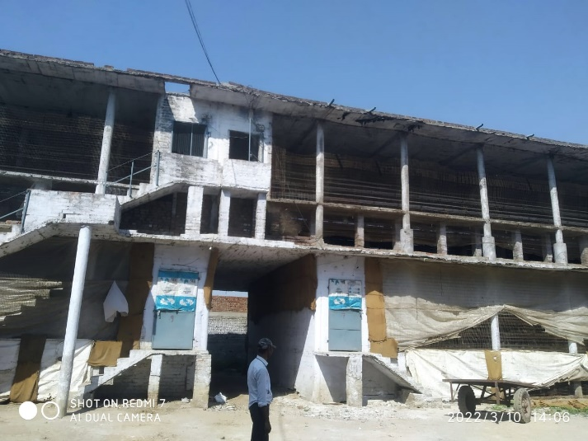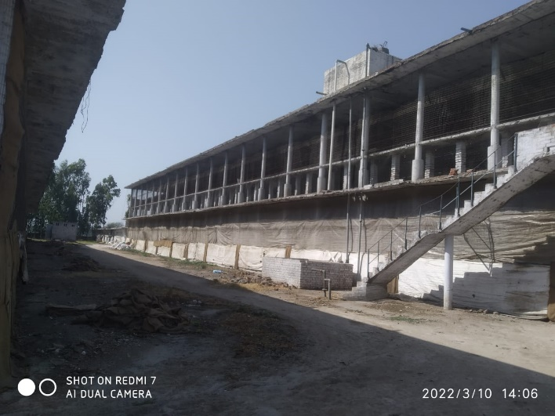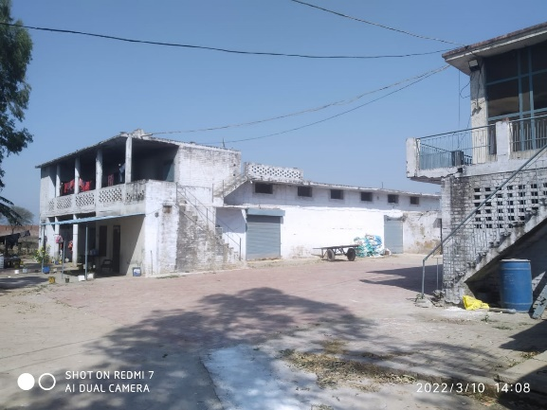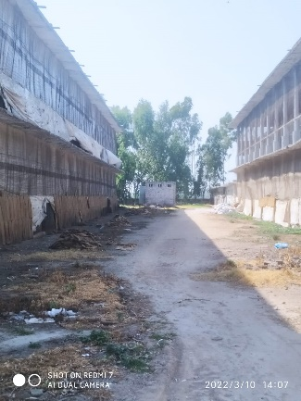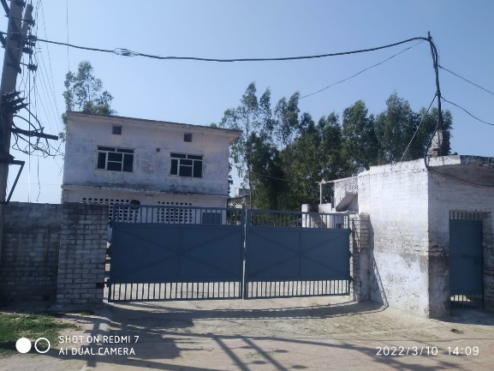
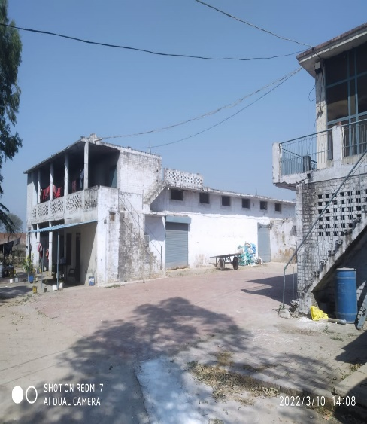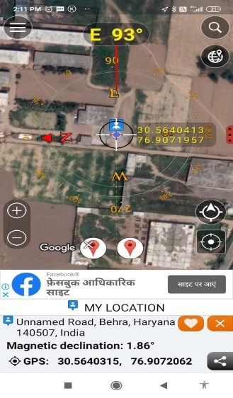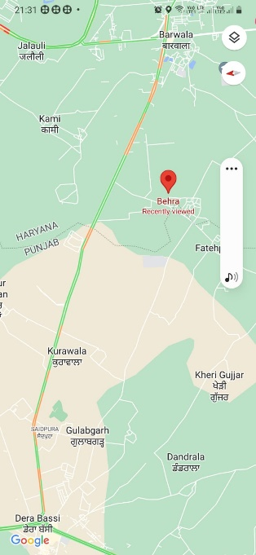
Photos of the Property have been attached as above Google view of location Google Location

Signature of Valuer
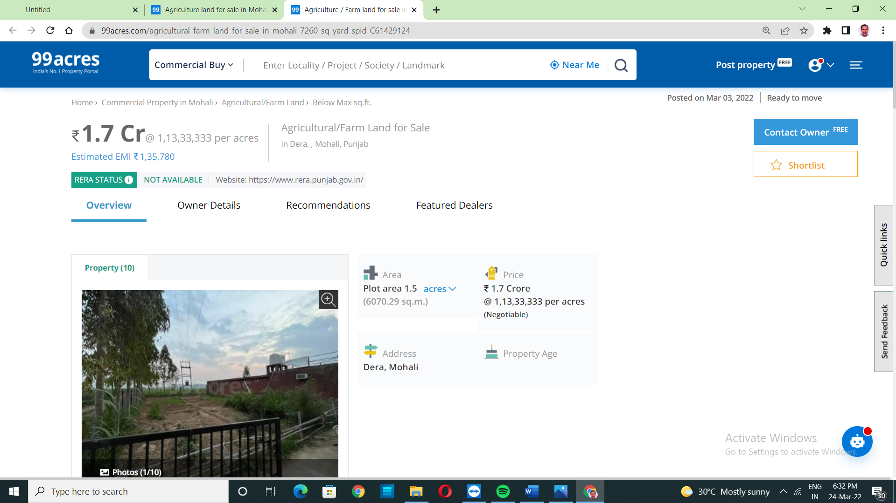
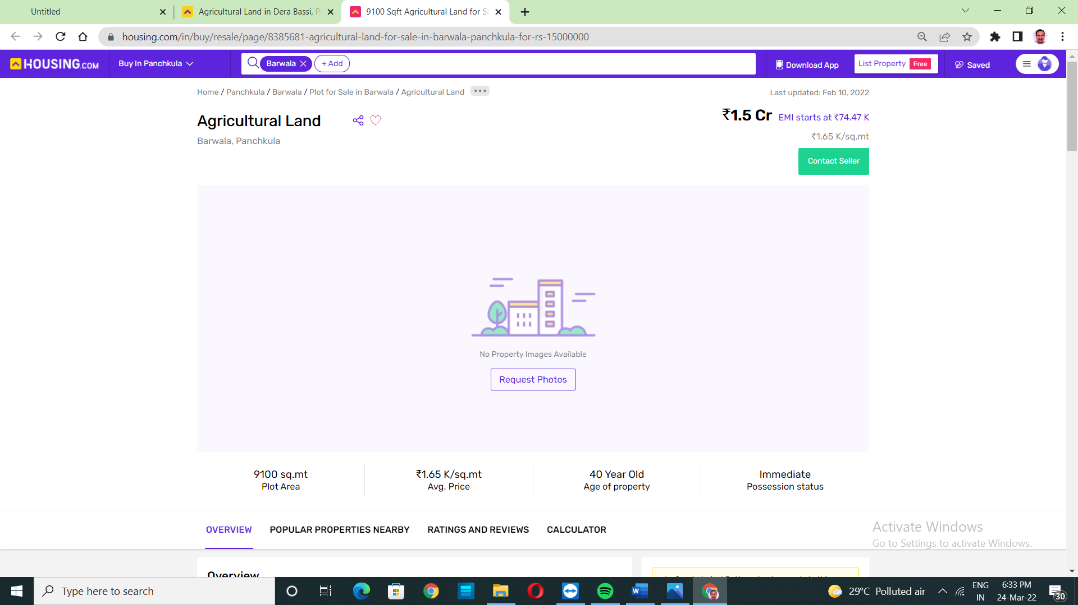
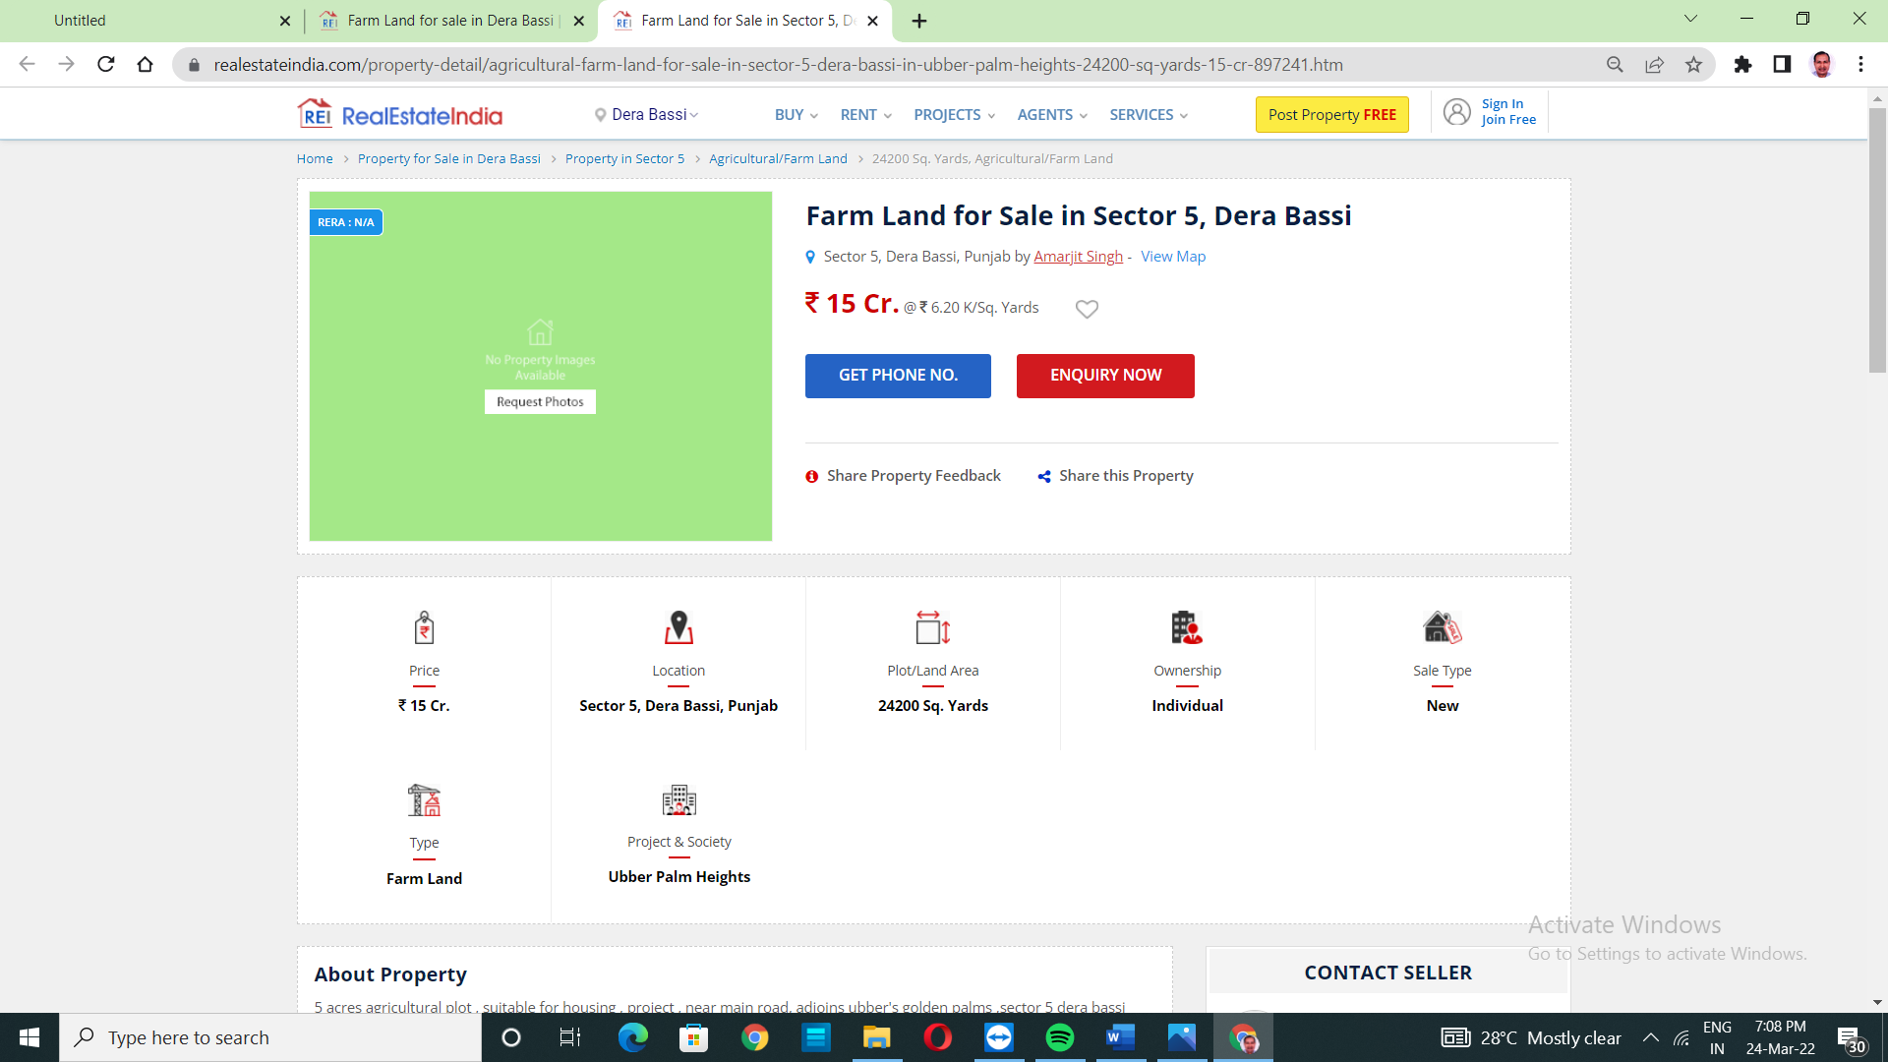

Assessment of rate for 7.55 Bigha, Poultry Land in Village Behra, Tehsil-Derabassi, Distt. SAS Nagar
The Rates of Agricultural Land in Village Behra, Tehsil-Derabassi, Distt. SAS Nagar Mohali discussed with property dealers working in this area & neighbours. They told the rates between Rs. 22.00lac to 25.00lac per Bigha. Depending on the size , location, direction , front width abutting road etc. The plot such as under valuation is not available less than the market rate i.e. Rs. 23.00lac per Bigha.
The real estate dealers contacted on phone on dt 24.03.2022 :1.Garg Associates(Rajiv Garg ) ,Barwala Road ,Derabassi Mob. 7307334455,2.Dogra Estate(Sanjiv Dogra), Barwala Road ,Derabassi mob.9872309664 and 3. Jitender Panesar ,Mob. 9815046811
Present market value of Property is assessed Rs. 23.00 lac per Bigha as on date and adopted for valuation.

Signature of Valuer

Collector rate of Tehsil Derabassi, Distt. Mohali(Pb.)
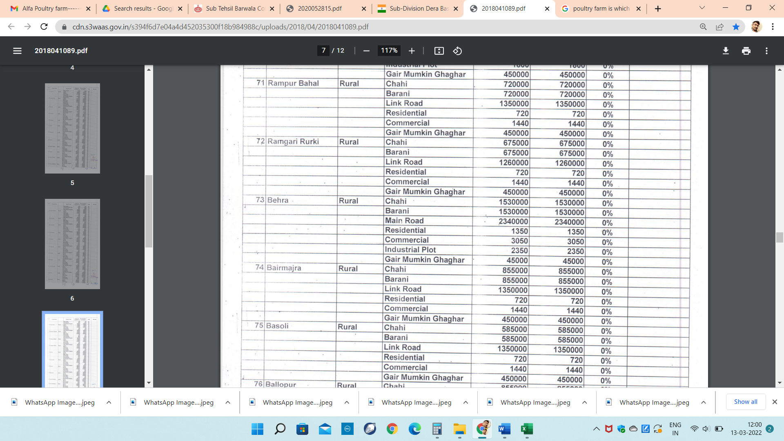

Downloaded document
Signature of Valuer

